Batch: A1 Roll No.: 16010123012
Experiment / Assignment / Tutorial No.: 06

Title: Implementation of Neural network activation functions and Hebbian learning

Aim: To understand & implement activation functions and Hebbian learning using python.
Expected Outcome of Experiment:
CO3: Understand and describe the mathematical foundation behind deep learning architectures.
Books/ Journals/ Websites referred:
- Jacek M. Zurada , “Introduction to Artificial Neural System ”, 1992 , West Group
Theory:
Neural Network
Neural networks, sometimes referred to as connectionist models, are parallel-distributed models that have several distinguishing features-
1) Processing Units (Neurons)
A neural network contains a set of processing units or neurons. Each neuron receives inputs, performs computations, and produces an output.
2) Activation State
Each neuron has an activation state, which represents the current output of that neuron after processing the input signal.
3) Weighted Connections
Neurons are interconnected through weighted connections.The connection between neuron $j$and neuron $k$is represented by a weight: $w_{jk}$
This weight determines the strength and influence of neuron $j$'s signal on neuron $k$.
- Positive weight - excitatory effect
- Negative weight - inhibitory effect
4) Propagation Rule
The propagation rule determines how the input signals from connected neurons are combined. Typically, the effective input is calculated as:
$$net=∑w_{i}x_{i}+b$$
where:
- $x_{i}$= input signals
- $w_{i}$= connection weights
- $b$= bias
5) Activation Function
The activation function transforms the net input into the neuron’s output.
Examples: Binary Step , Sigmoid , ReLU , Bipolar Sigmoid
It introduces non-linearity, allowing the network to learn complex patterns.
6) External Input (Bias / Offset)
Each neuron may also include an additional external input called bias or offset.
The bias helps shift the decision boundary and improves the flexibility of the model.
7) Learning Rule
A neural network uses a learning rule to update its weights based on the input data.
Examples: Hebbian learning , Perceptron learning , Backpropagation
This enables the network to improve performance over time.
8) Environment
The network operates within an environment that provides:
- input signals
- expected outputs (if supervised)
- error signals (for correction)
The environment determines how the network interacts with real-world data.
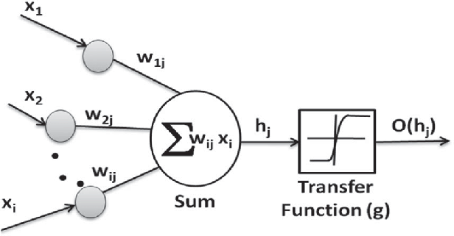
Fig 1: Structure of Artificial Neuron

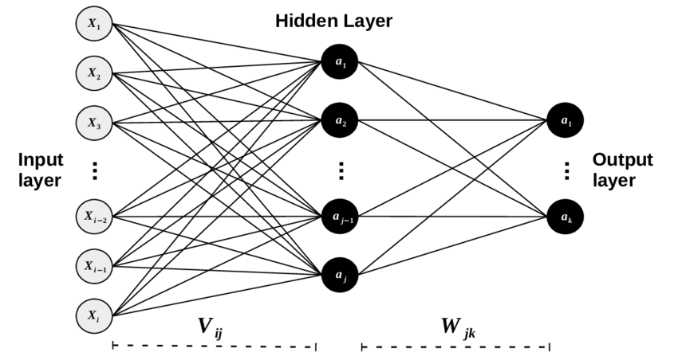

Fig 2: Artificial Neural network with hidden layers

Activation Functions
In a neural network, each neuron first computes the net input as the weighted sum of inputs. This net input is then transformed using a scalar-to-scalar mathematical function, called the activation function, to produce the neuron’s final output.
The output of one neuron is then passed to one or more neurons in the next layer.
Activation functions are essential because they:
- introduce non-linearity
- control the output range
- help the network learn complex patterns
- decide the final response of a neuron
Activation functions with a bounded range are often called squashing functions.
Some of the most commonly used activation functions are:
1) Identity (Linear) Function
The Identity function, also called the Linear activation function, directly returns the input as output. It applies identity operation on your data and output data is proportional to the input data.
f(x)=x

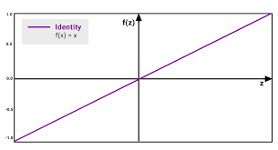
Fig 3: Linear Activation function graph

- Binary Step Function
The Binary Step function produces:
- 1 when input exceeds threshold
- 0 otherwise
$$f(x)=\{1, x≥0 0, x<0$$
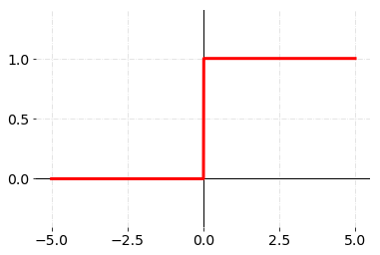
Fig 4: Binary Activation function graph

- Sigmoid function:
A Sigmoid function is a mathematical function which has a characteristic S-shaped curve. There are a number of common sigmoid functions, such as the logistic function, the hyperbolic tangent, and the arctangent In machine learning, the term sigmoid function is normally used to refer specifically to the logistic function, also called the logistic sigmoid function.
All sigmoid functions have the property that they map the entire number line into a small range such as between 0 and 1, or -1 and 1, so one use of a sigmoid function is to convert a real value into one that can be interpreted as a probability.
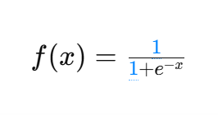
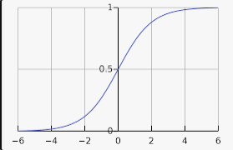
Fig 5: Sigmoid Activation function graph
The Sigmoid function is an S-shaped curve that maps input into (0,1).
4) Bipolar sigmoid function: this function is defined as follows:
A bipolar sigmoid function is of the form
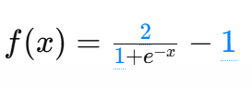
The range of values of sigmoid functions can be varied depending on the application. However, the range of (-1,+1) is most commonly adopted.

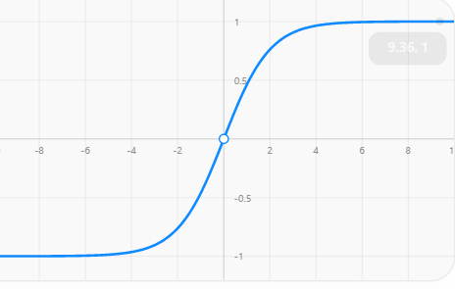
Fig 6:Bipolar Sigmoid Activation function graph
5) ReLU function: this function is defined as follows:
The rectified linear activation function or ReLU for short is a piecewise linear function that will output the input directly if it is positive, otherwise, it will output zero. It has become the default activation function for many types of neural networks because a model that uses it is easier to train and often achieves better performance.
The Rectified Linear Unit (ReLU) outputs:
- input directly if positive
- zero otherwise
$$f(x)=max⁡(0,x)$$
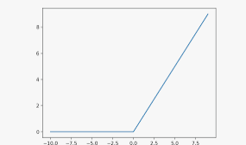
Fig 7: ReLu Activation function graph

6) Ramp function:
The Ramp function is a bounded piecewise linear activation function.
It produces:
- 0 for negative inputs
- input value for inputs between 0 and 1
- 1 for values greater than 1
$$f(x)=\{0, x<0 x, 0≤x≤1 1, x>1$$
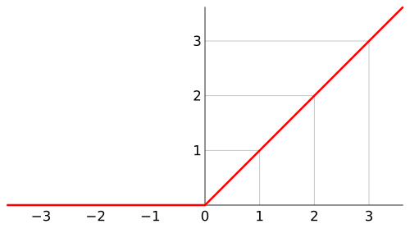
Fig 8: Ramp Activation function graph
Hebbian Learning
Hebbian learning is one of the earliest and most fundamental learning rules used in artificial neural networks. It is a biologically inspired learning mechanism based on the principle: Neurons that fire together, wire together.
This means that when an input neuron and an output neuron are activated simultaneously, the connection (weight) between them becomes stronger.
Hebbian learning is mainly used for - pattern association , feature correlation , unsupervised learning , memory models , dimensionality reduction
Mathematical Rule
The Hebbian learning rule updates the weight using:
$$w=w+ηxy$$
where:
$w$= weight vector
$x$= input vector
$y$= target/output neuron activation
$η$= learning rate
This rule strengthens the weights whenever the input and output activate together.
Working Principle of Hebbian learning rule
The learning process follows these steps:
- Initialize weights to zero or small random values
- Present input vector to the neuron
- Compute neuron output using an activation function
- Update weights using Hebbian rule
- Repeat for all training samples
Common choices of activation function in Hebbian learning rule:
- Binary Step Activation
- Bipolar Step / Bipolar Sigmoid
Bipolar activation is often preferred because it provides:
- symmetric learning
- better weight interpretation
- balanced positive and negative correlations

Lab Task:
  - Implement the 6 Activation functions and plot the graph for each
  - Write a Python program to implement Hebbian learning for the AND gate using binary and bipolar activation functions. Compare the learned weights.
  - Implement Hebbian learning on the Breast Cancer Wisconsin dataset using two numerical features. Convert diagnosis labels into bipolar form, normalize the inputs, train the Hebbian model, and interpret how the learned weights relate to malignant and benign tumor characteristics.
Link of the dataset: https://www.kaggle.com/datasets/uciml/breast-cancer-wisconsin-data

Implementation Details:
Task 1
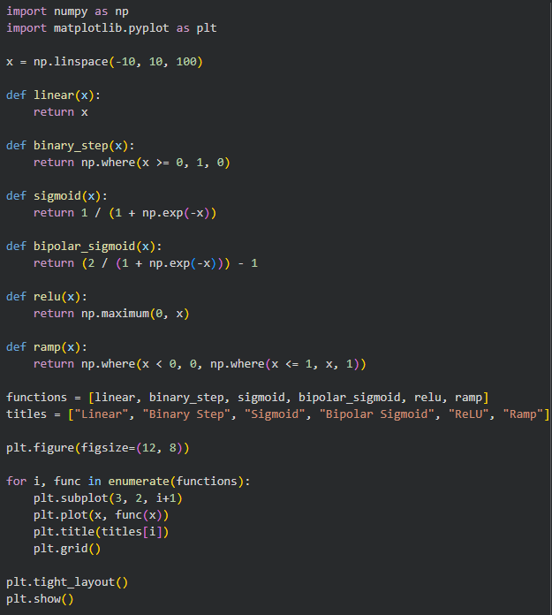

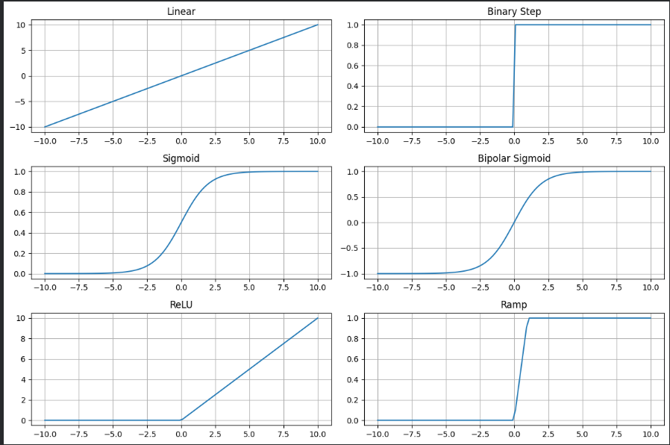
Task 2:
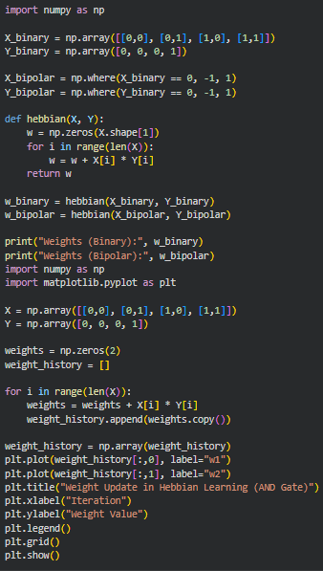
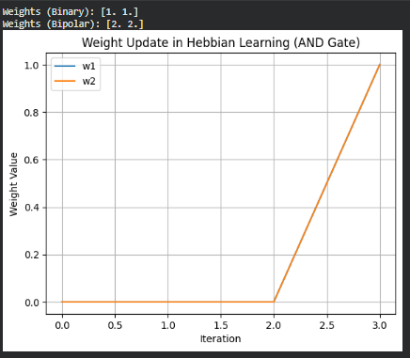

Task 3:
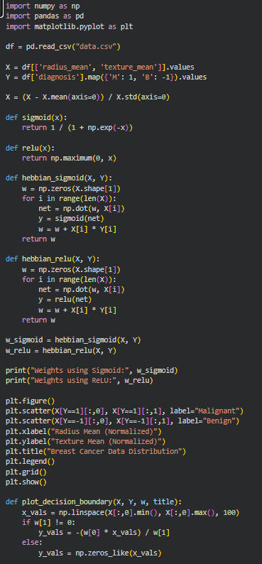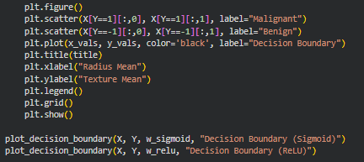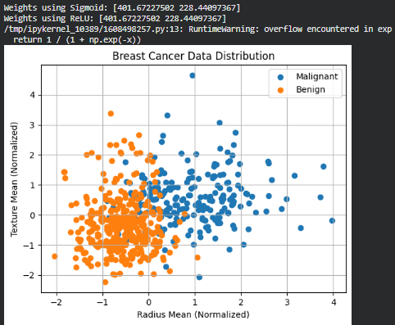
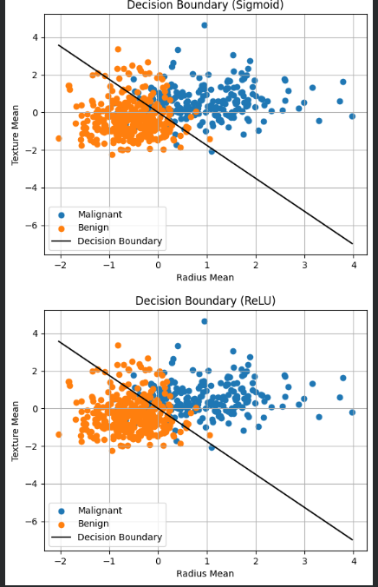
Conclusion: In this experiment, various neural network activation functions such as Linear, Binary Step, Sigmoid, Bipolar Sigmoid, ReLU, and Ramp were implemented and analyzed. These functions were observed to introduce non-linearity and control the output range of neurons, enabling neural networks to learn complex patterns. Additionally, Hebbian learning was implemented for the AND gate and a real-world dataset, demonstrating how weights are updated based on correlation between input and output neurons.
Post Lab:
- Suggest the applications of each activation functions
• Linear (Identity): Used in regression problems where output is continuous.
• Binary Step Function: Used in simple classification tasks like perceptron models and logic gates.
• Sigmoid Function: Used in binary classification problems and output layers where probability is required.
• Bipolar Sigmoid Function: Used in neural networks where outputs are in range (-1, 1), useful for symmetric data.
• ReLU (Rectified Linear Unit): Widely used in deep learning hidden layers due to faster training and reduced vanishing gradient problem.
• Ramp Function: Used in bounded output systems and control applications.
- Find the weights after one iteration for hebbian learning of a single neuron network. Start with initial weights W=[1,-1] and Inputs as X1=[1,-2] X2=[2,3], x3[1,-1] and learning rate C=1.
Given: W = [1, -1], C = 1
Inputs: X₁ = [1, -2], X₂ = [2, 3], X₃ = [1, -1]
Rule: W_new = W + C × X
Step 1: W₁ = [1, -1] + [1, -2] = [2, -3]
Step 2: W₂ = [2, -3] + [2, 3] = [4, 0]
Step 3: W₃ = [4, 0] + [1, -1] = [5, -1]
Final Weights: W = [5, -1]

- Why are different activation functions used in hidden layers and output layers of neural networks?
Different activation functions are used because each layer has a different role. Hidden layers require non-linear activation functions like ReLU or sigmoid to capture complex patterns and relationships in data. The output layer uses activation functions based on the problem type, such as sigmoid for binary classification, softmax for multi-class classification, and linear for regression. This ensures that outputs are in the correct format and range.
- Why is Hebbian learning suitable for correlation learning but not ideal for complex classification tasks?
Hebbian learning strengthens connections based on correlation between neurons but does not use error correction. It lacks a feedback mechanism to adjust mistakes, making it unsuitable for complex classification tasks. It works well for pattern association and feature learning but cannot optimize performance like algorithms such as backpropagation.

